1. Create MariaDB db. on ec2.

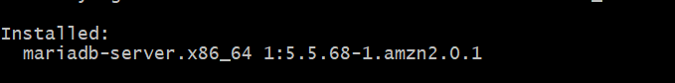

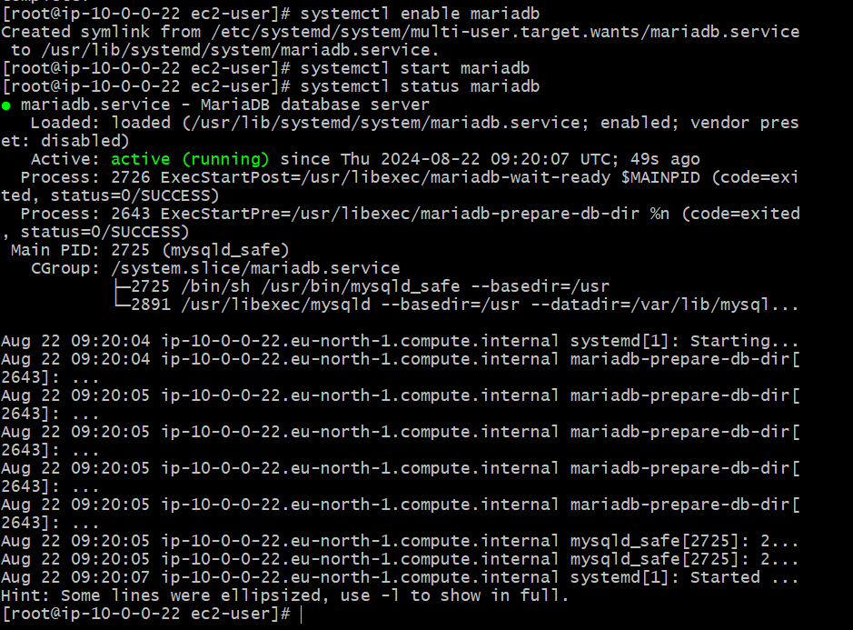

yum -y install mariadb-server wget

systemctl enable mariadb

systemctl start mariadb

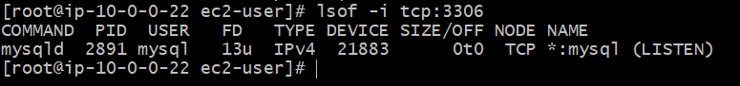

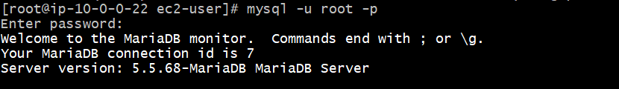

**Connect to MariaDB:** mysql -u root -p

**To check the data:** show databases;

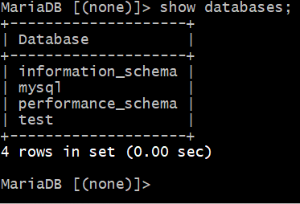

1. Insert some dummy data

CREATE TABLE table1 (id INT, name VARCHAR(45));

INSERT INTO table1 VALUES(1, 'Virat'), (2, 'Sachin'), (3, 'Dhoni'), (4, 'ABD');

SELECT * FROM table1;

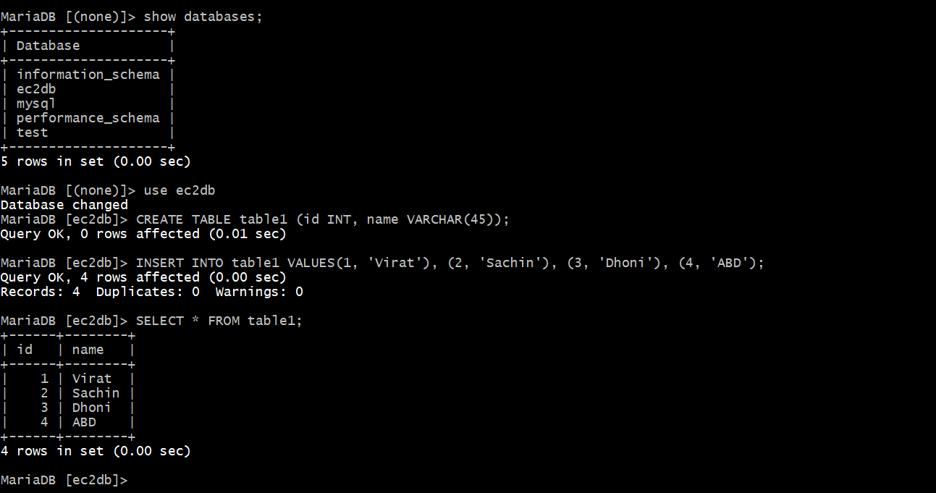

1. Take the backup of dummy data on ec2

mysqldump -u root -p database_name(ec2db) > file_name.sql(newbackup.sql)

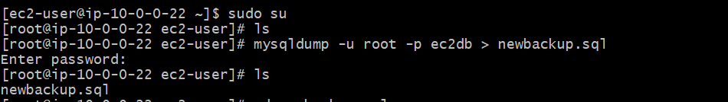

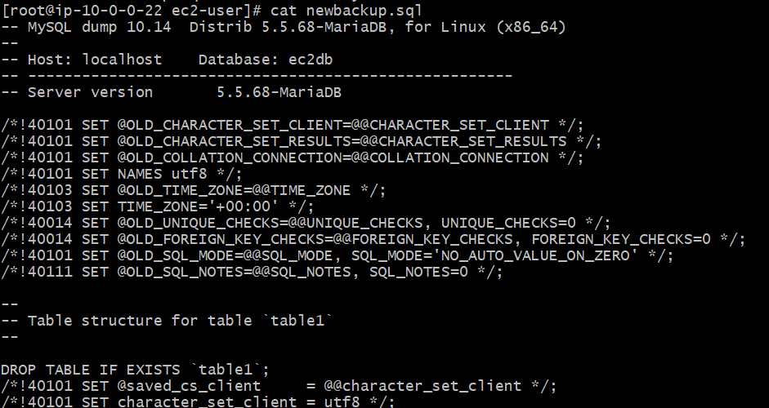

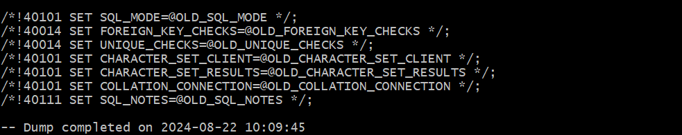

1. launch MariaDB RDS instance.

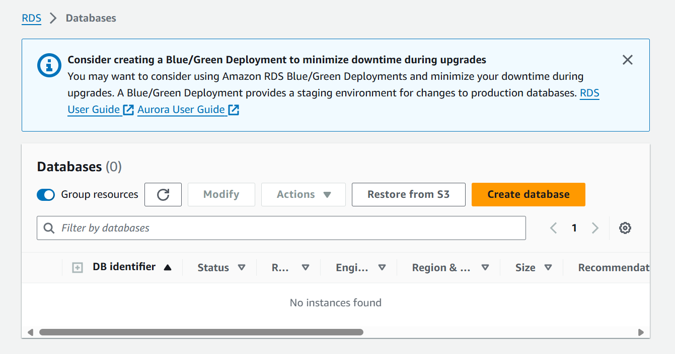

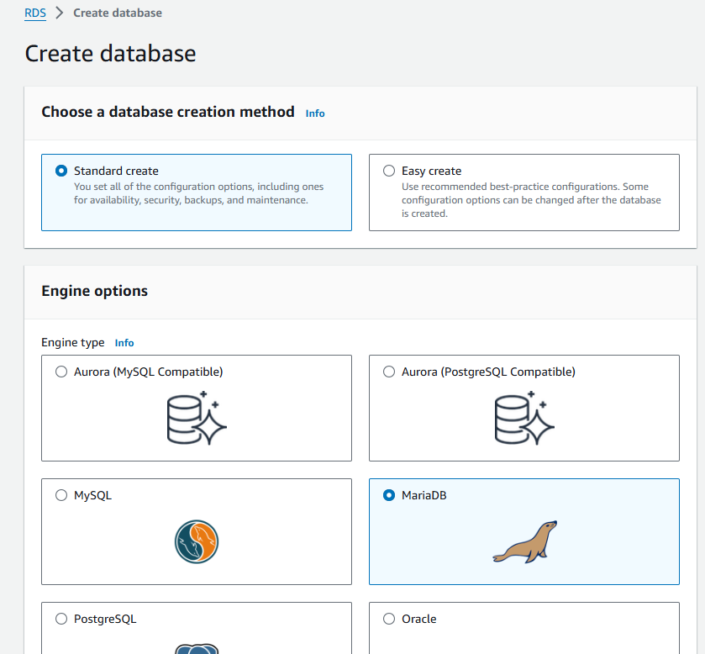

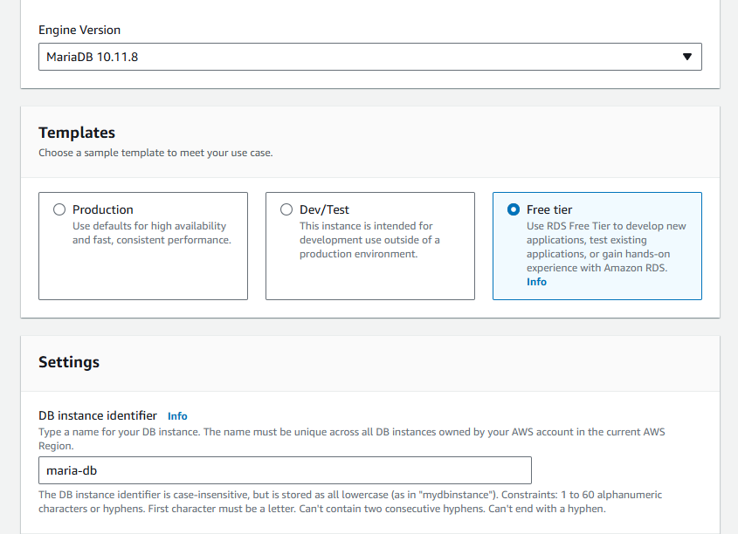

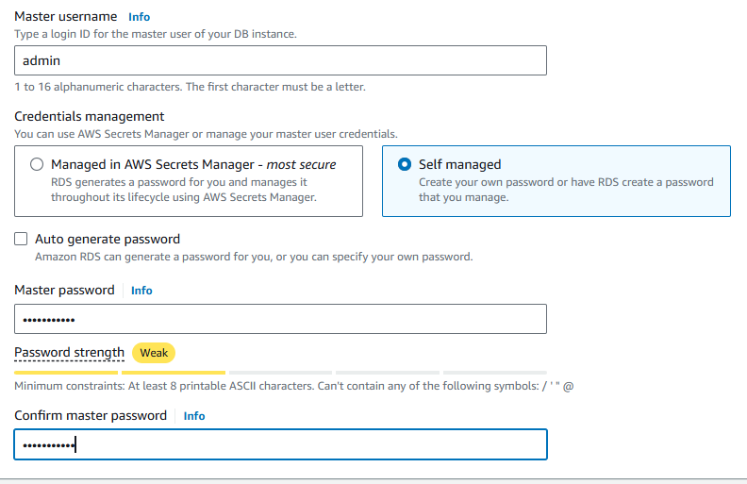

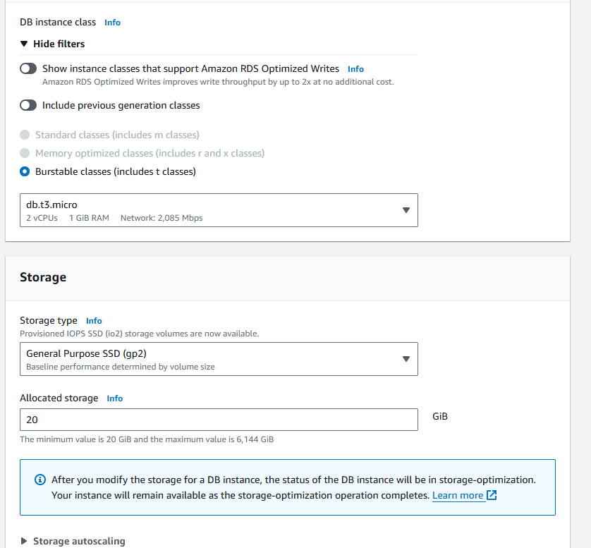

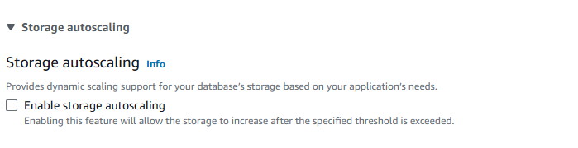

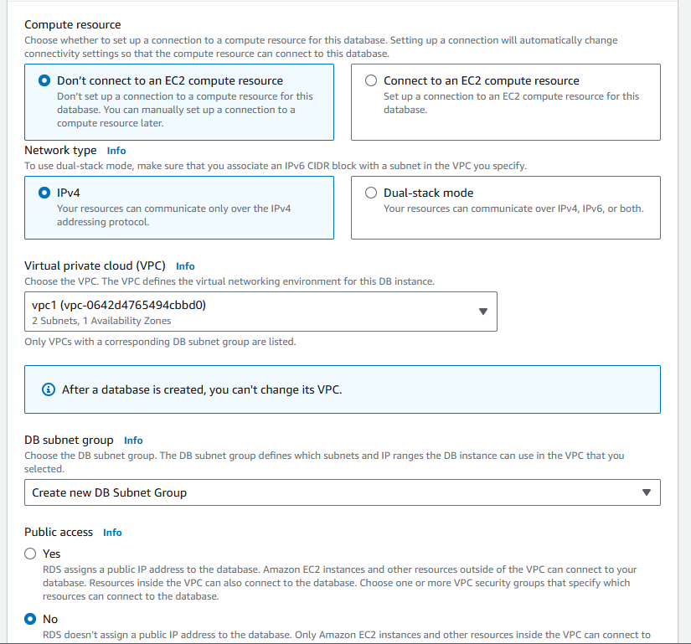

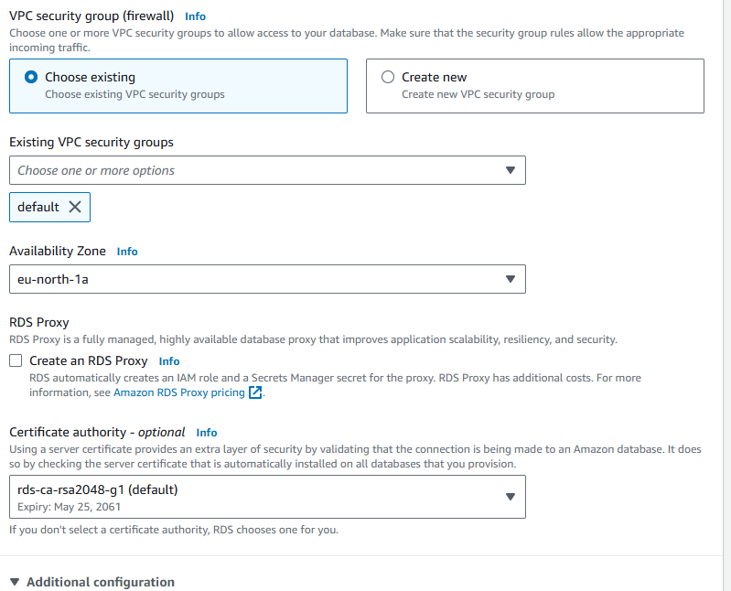

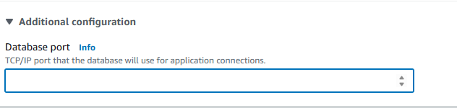

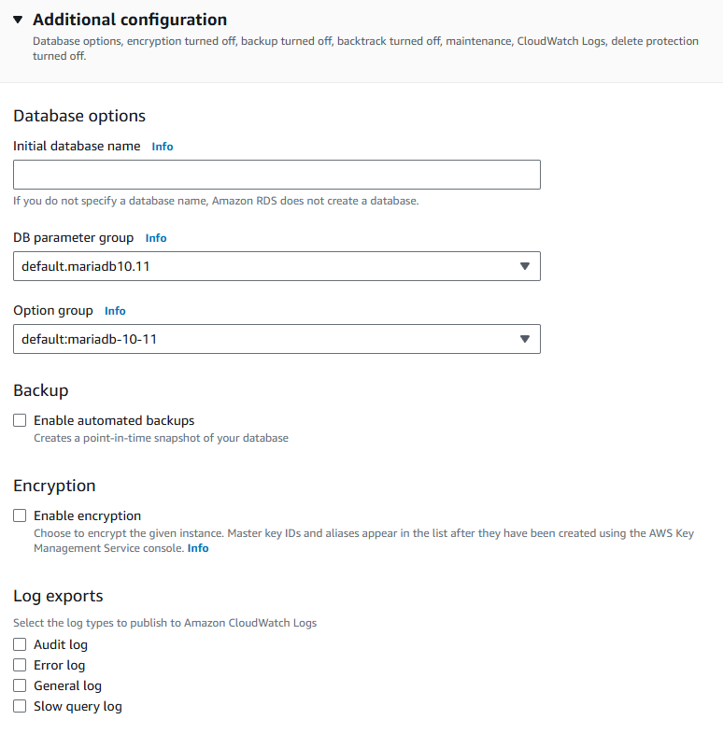

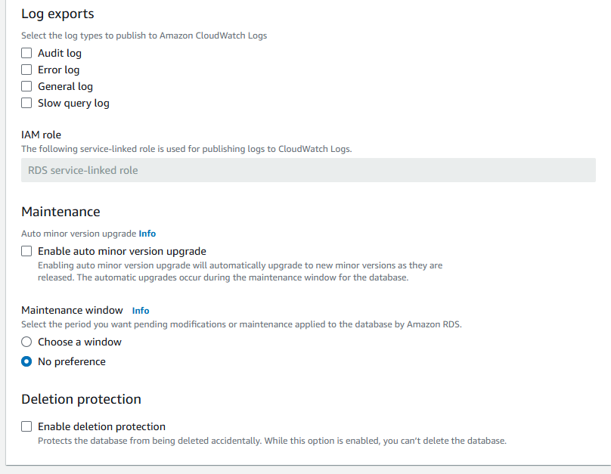

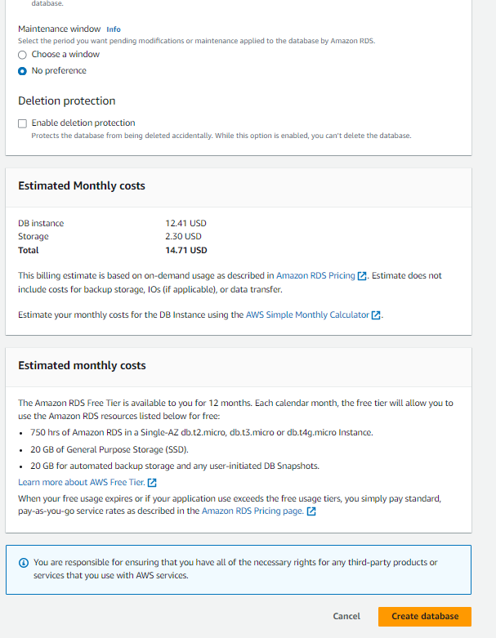

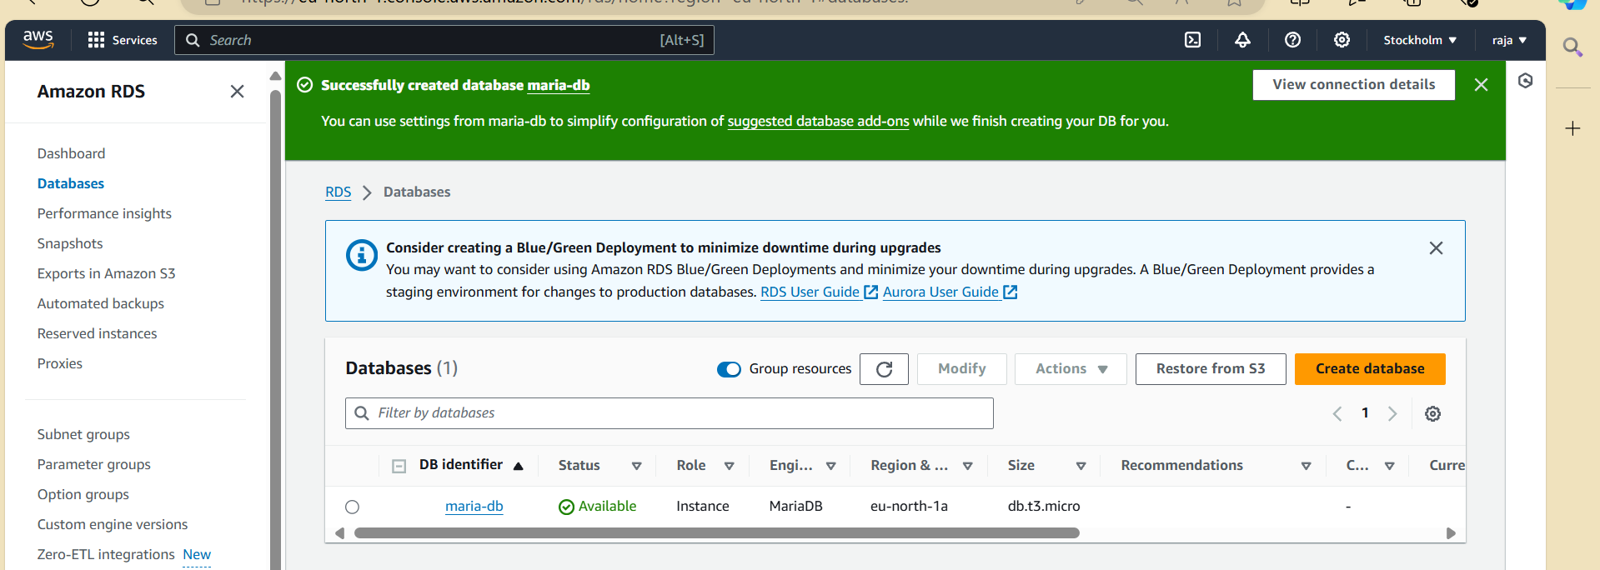

1. Migrate database from ec2 to RDS.

Get the dump of your existing DB on EC2

mysqldump -u root -p database_name > file_name.sql

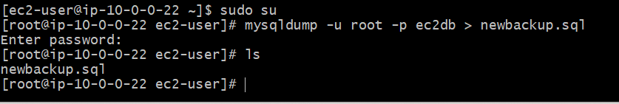

Migrate the DB dump that you have taken in step 1 to RDS

mysql -h <replace-rds-end-point-here> -P 3306 -u <user_name> -p database_name < ec2db.sql

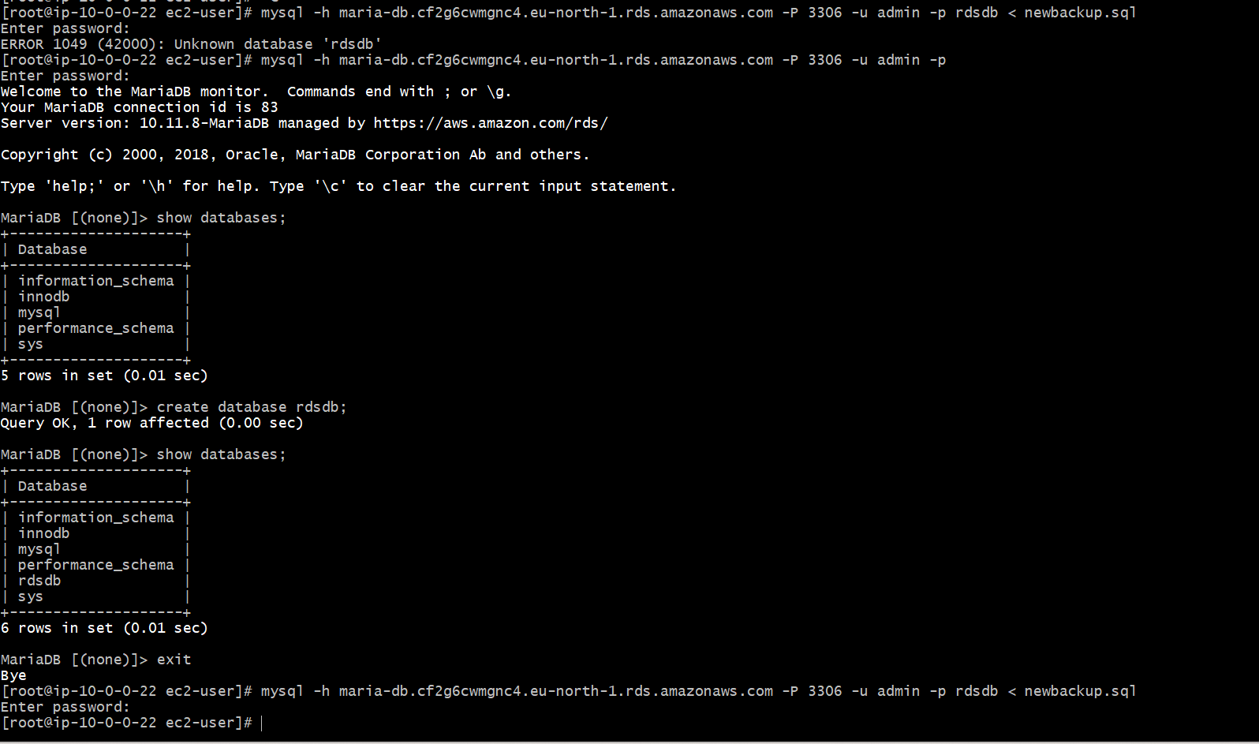

Connect to your RDS DB instance

MySQL -h <replace-rds-end-point-here> -P 3306 -u rdsuser -p

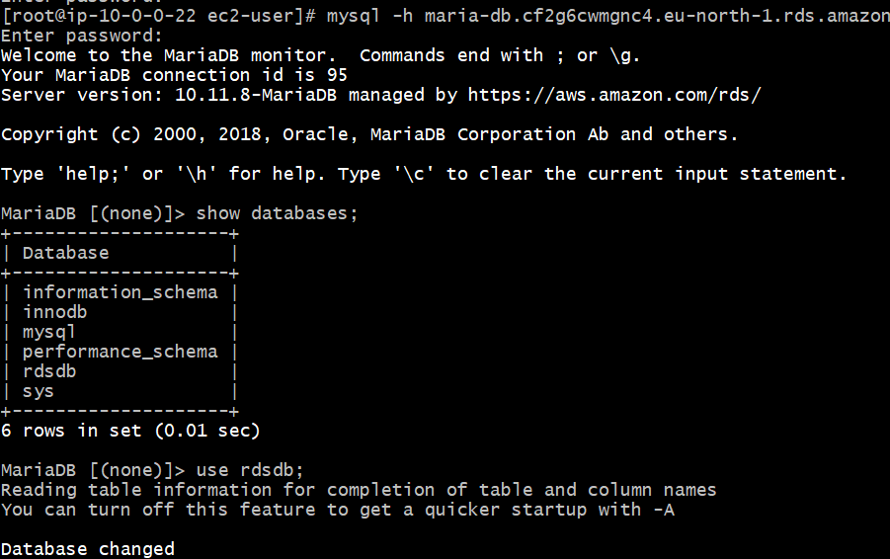

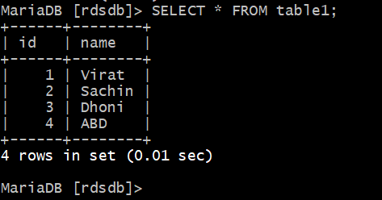

Switch to the database and verify the details.

USE rdsdb

SELECT * FROM table1;

1. Install MySQL db. on ec2

**yum install java-1.8\***  
**yum update**  
**sudo wget**[**https://dev.mysql.com/get/mysql57-community-release-el7-11.noarch.rpm**](https://dev.mysql.com/get/mysql57-community-release-el7-11.noarch.rpm)  
**sudo yum localinstall mysql57-community-release-el7-11.noarch.rpm**  
**rpm --import**[**https://repo.mysql.com/RPM-GPG-KEY-mysql-2022**](https://repo.mysql.com/RPM-GPG-KEY-mysql-2022)  
**sudo yum install mysql-community-server**  
**systemctl start mysqld**  
**systemctl status mysqld**

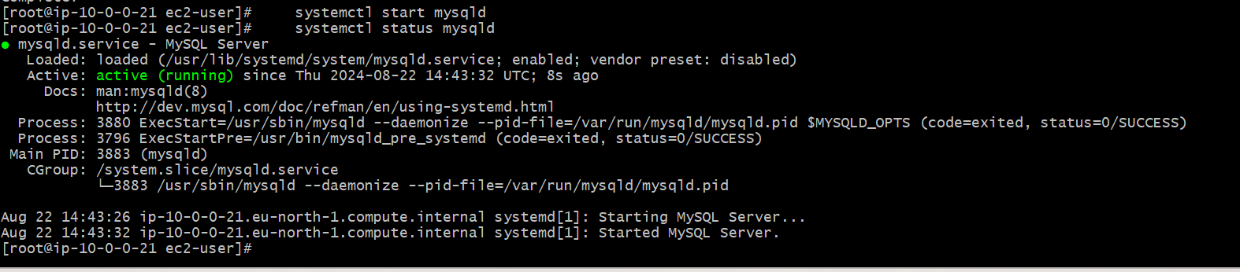

7) Launch MySQL RDS image

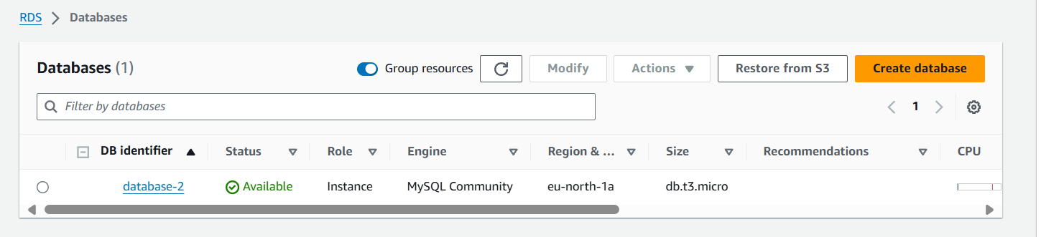

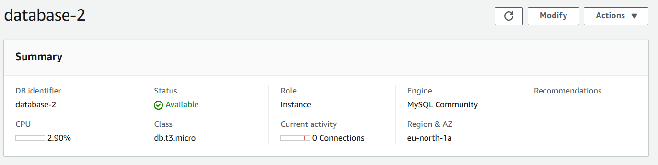

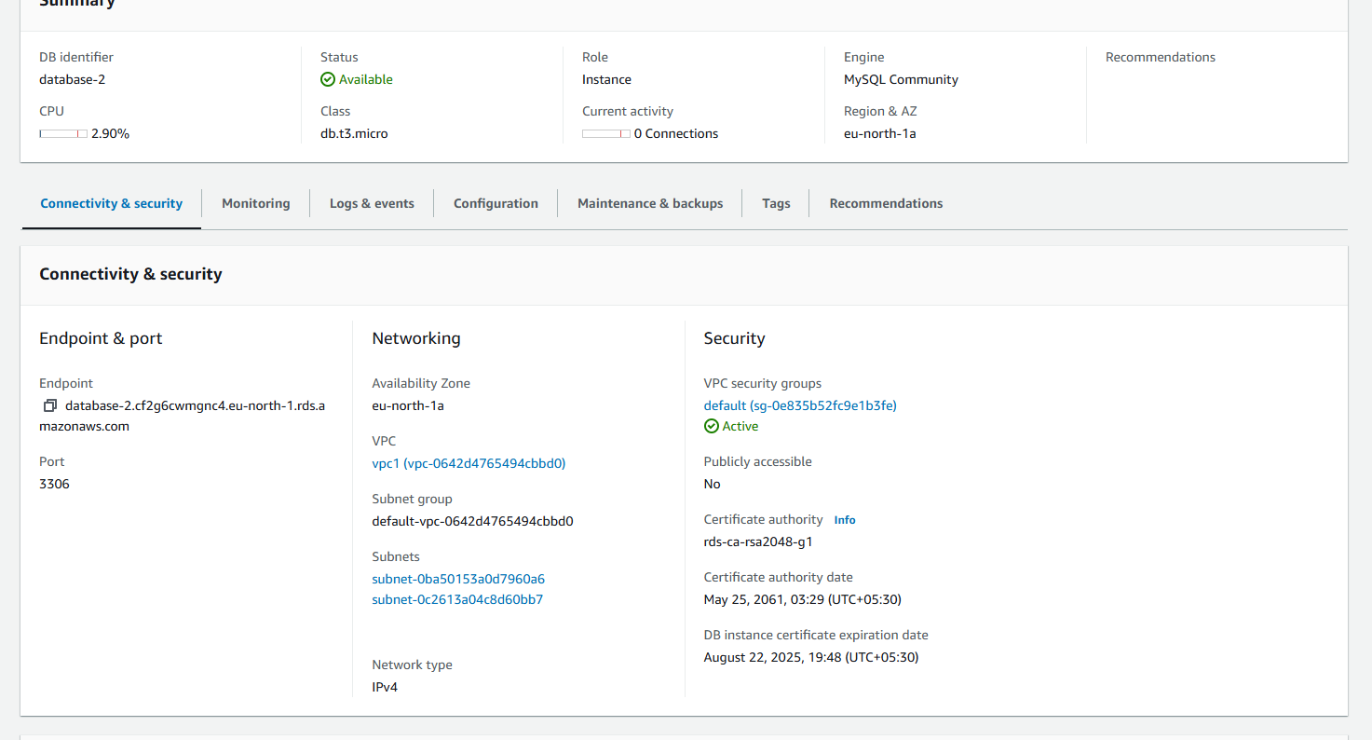

8) Configure multi-AZ

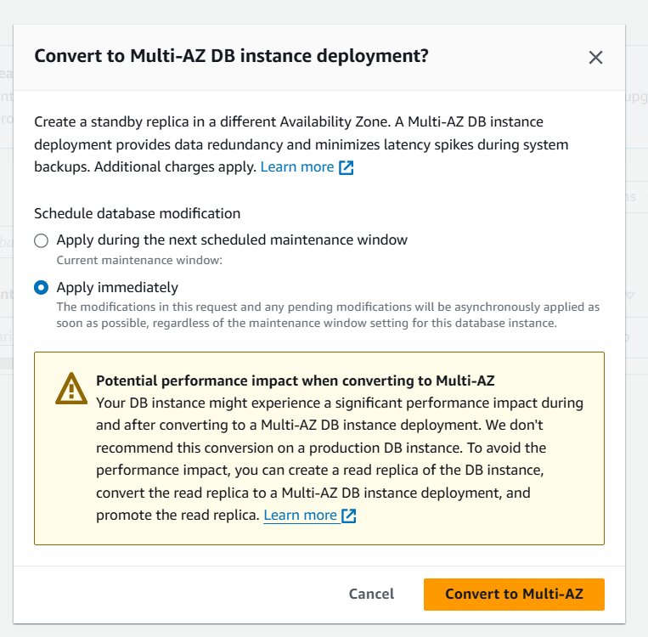

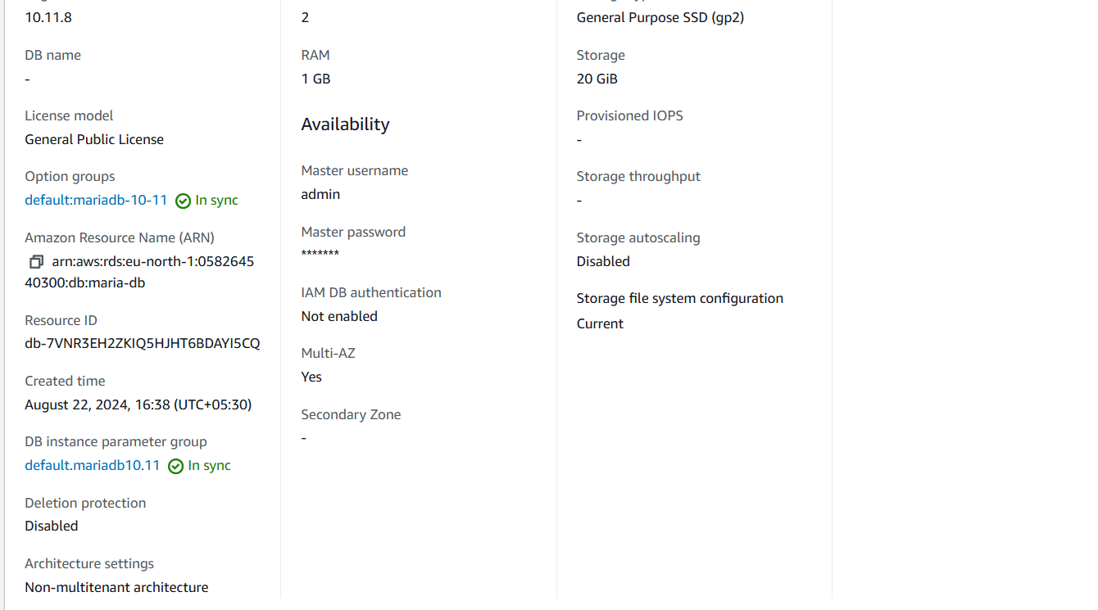

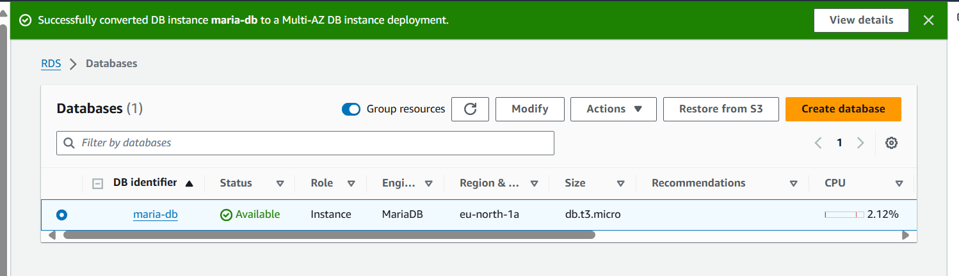

9) Take Backup of dB and restore the DB

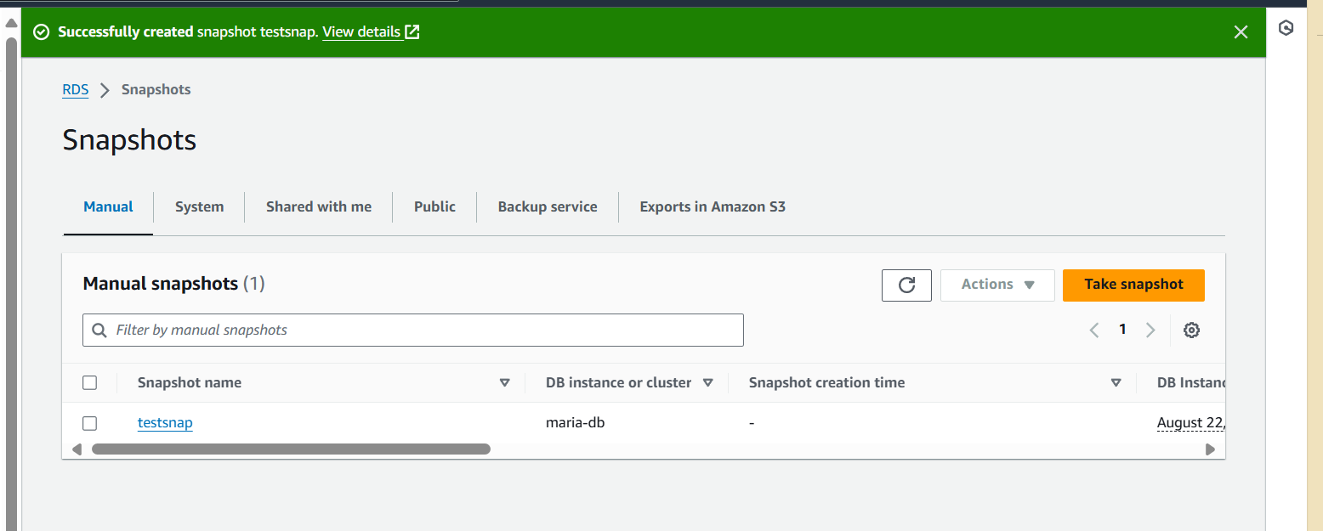

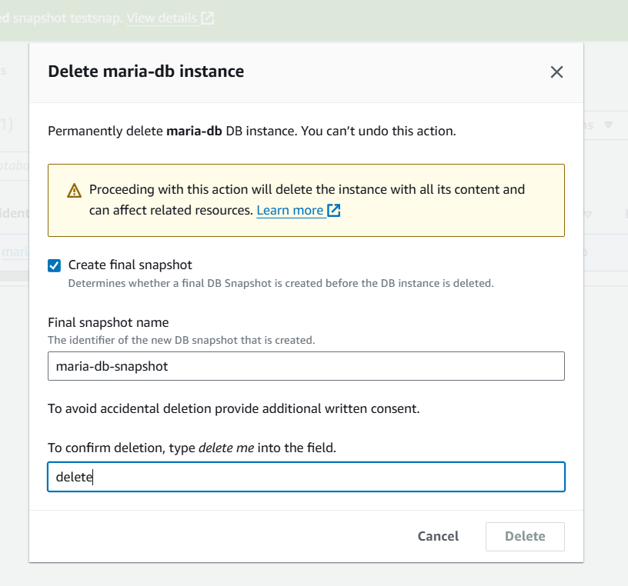

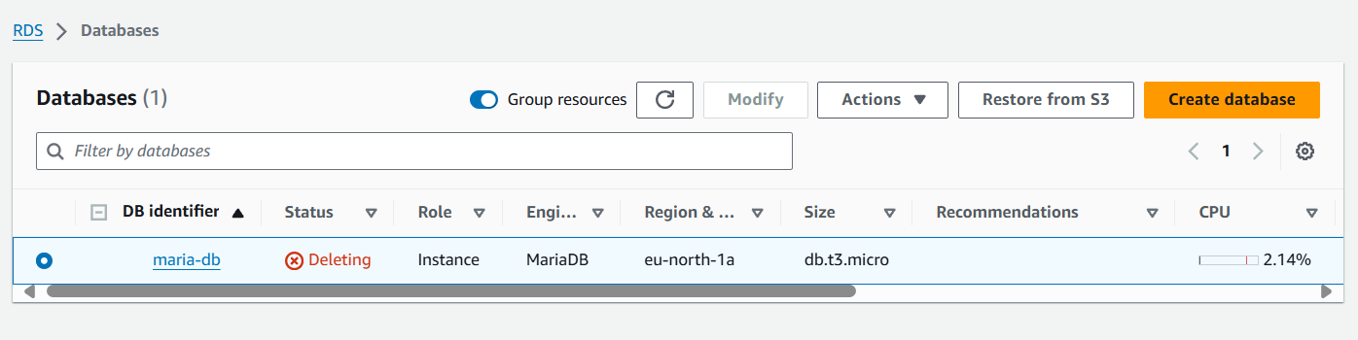

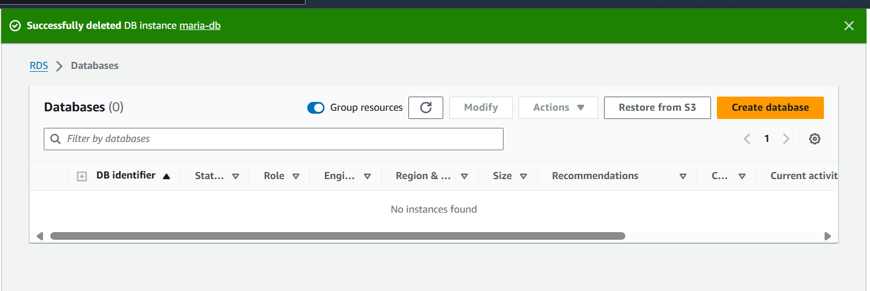

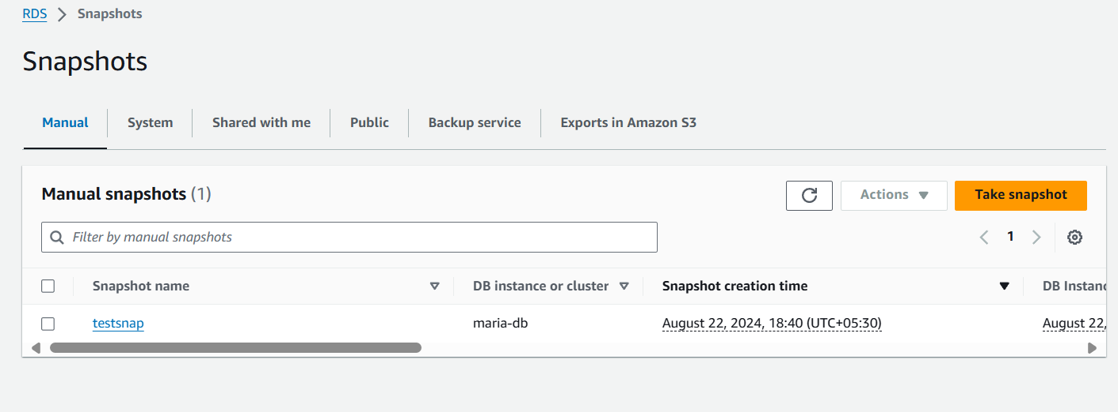



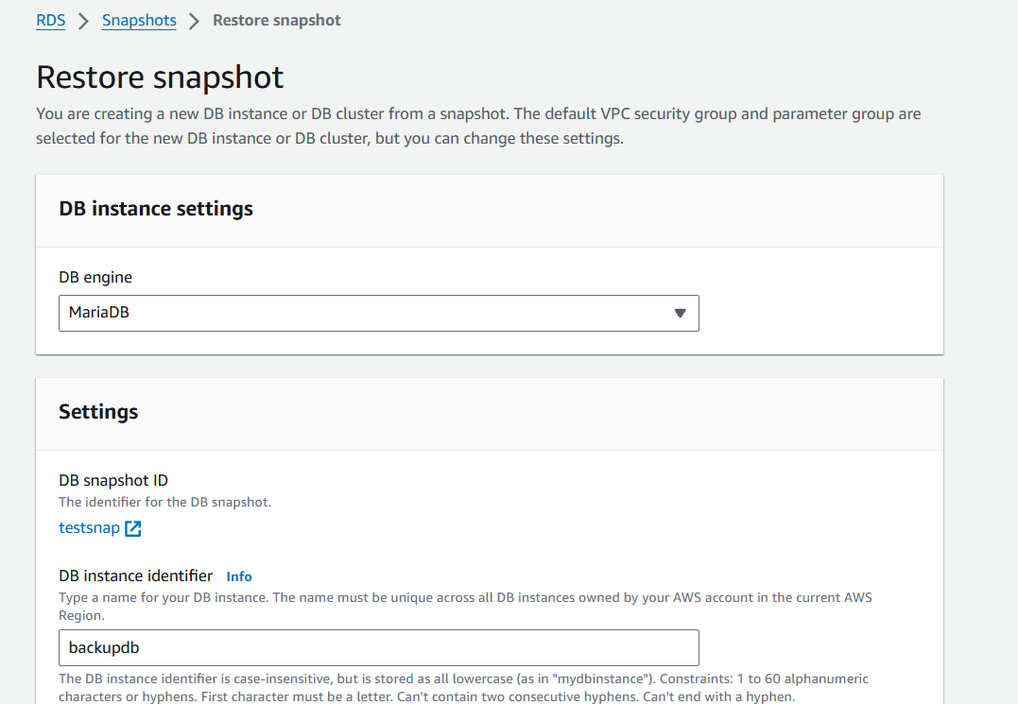

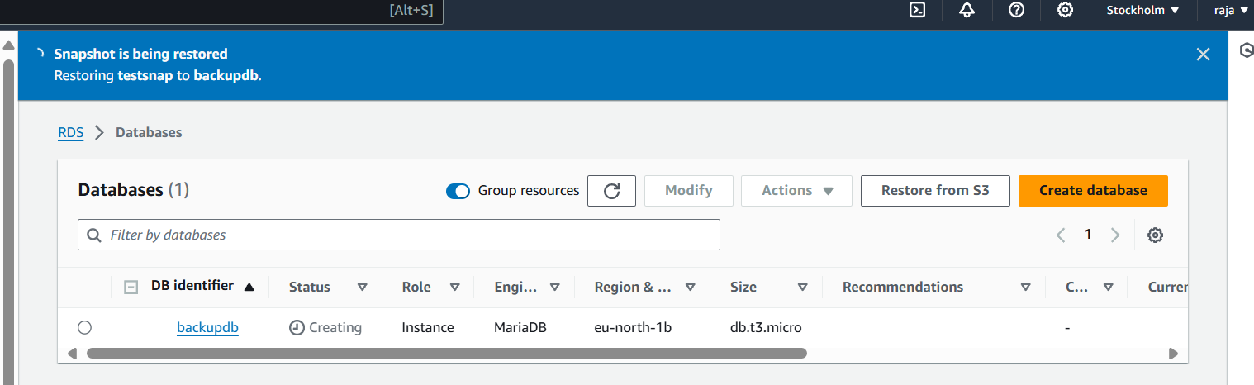

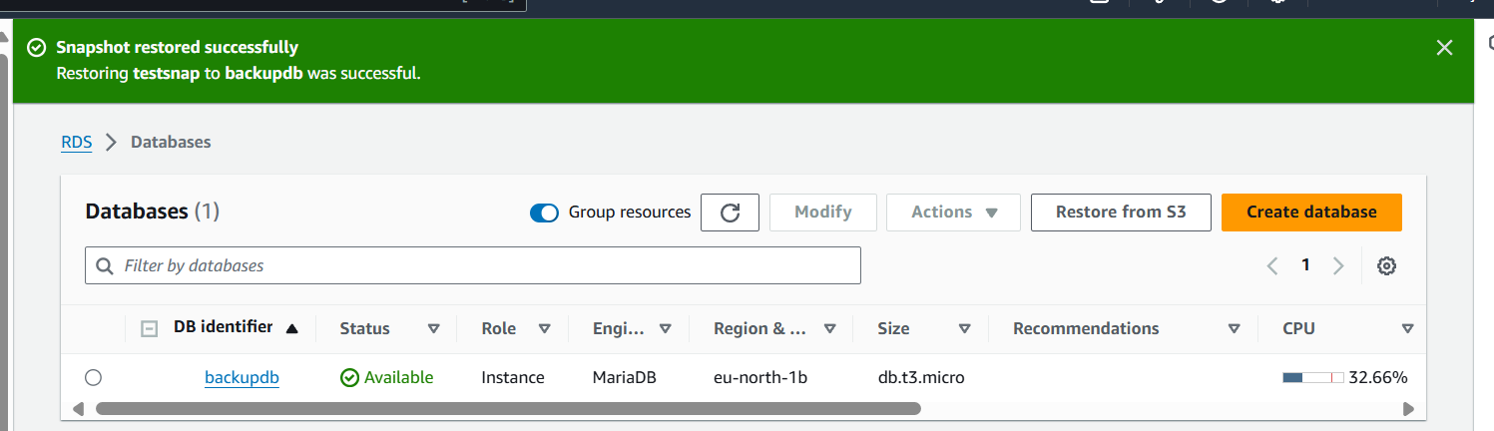

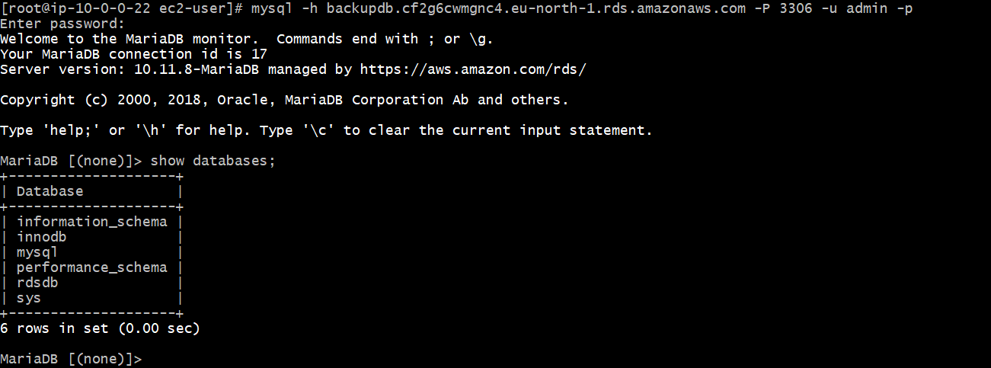

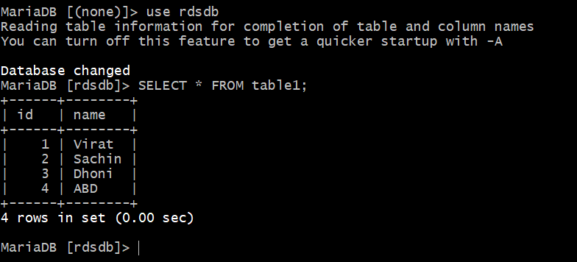

10) Create Read replica

